
Rockefeller University Bleeding History Phenotyping System User’s Manual
Rockefeller University Informatics Core
Version 2.0
5/6/2010
Contents

I. Phenotype Recording Instrument 3
1. The Phenotype Recording Instrument 3
2. Login and Basic Navigation 3
3. The Bleeding History Questionnaire 8
4. Laboratory Data Entry 14
II. PRI Reports 18
1. PRI Demographics 18
2. PRI Graph 19
3. PRI Individual Reports 19
4. PRI Aggregate Reports 21

I. Phenotype Recording Instrument

1. The Phenotype Recording Instrument (PRI) is a Web-based data collection instrument. It includes a suite of instruments for collecting standardized bleeding histories as well as recording laboratory data pertaining to hemostasis. Further information can be found at the Rockefeller University Bleeding History Phenotyping System Repository (RUBHPSR) Website: http://bh.rockefeller.edu/RUBHPSR/index.html. To access the PRI, please direct your Web browser to: https://bh.rockefeller.edu/prat/

2. To log in:
A. If you are testing out the system for the first time, please refer to the “Limited User’s Manual for Evaluation of the PRI,” which can be accessed at http://bh.rockefeller.edu/RUBHPSR/Documentation.html
B. If you are a registered user, click the radio button labeled with the text “Log in as an authenticated user.” Three new fields (User ID, Password, and Site ID) will appear.
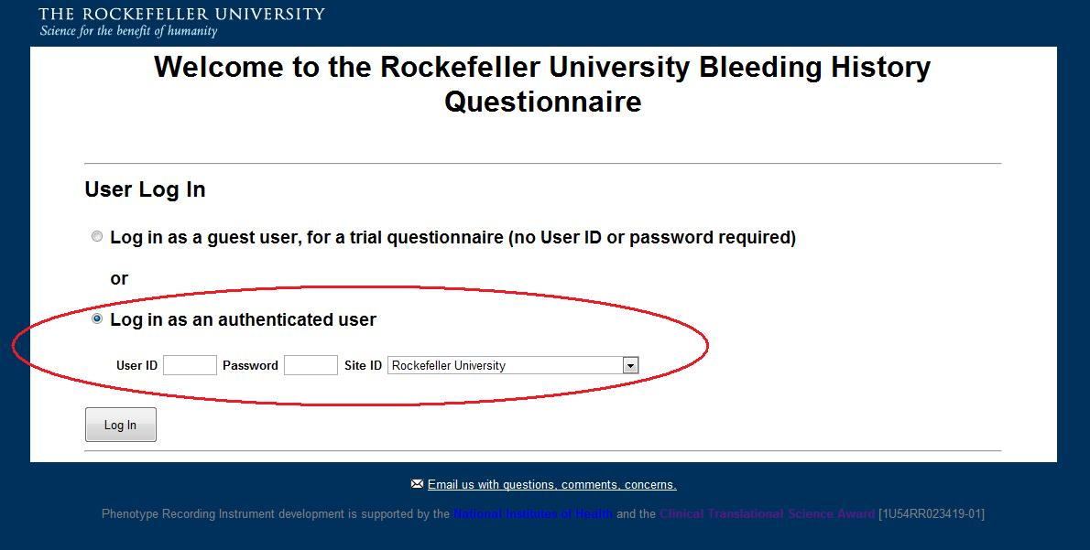
1) Fill out the login fields.
- User ID: Enter the ID number supplied to you by RUBHPSR staff. If you do not have a User ID, contact us by clicking the link that says “Email us with questions, comments, concerns.”
- Password: Enter the password supplied to you by RUBHPSR staff. After logging in, you will have the opportunity to change this password to suit your preference.
- Site ID: Select the institution where you are using the instrument. User ID’s are linked to Site ID’s, so if you do not select the site that you registered under, you will receive an error message.

2) Click the radio button labeled with the text “Log In.” You will be directed to this screen:

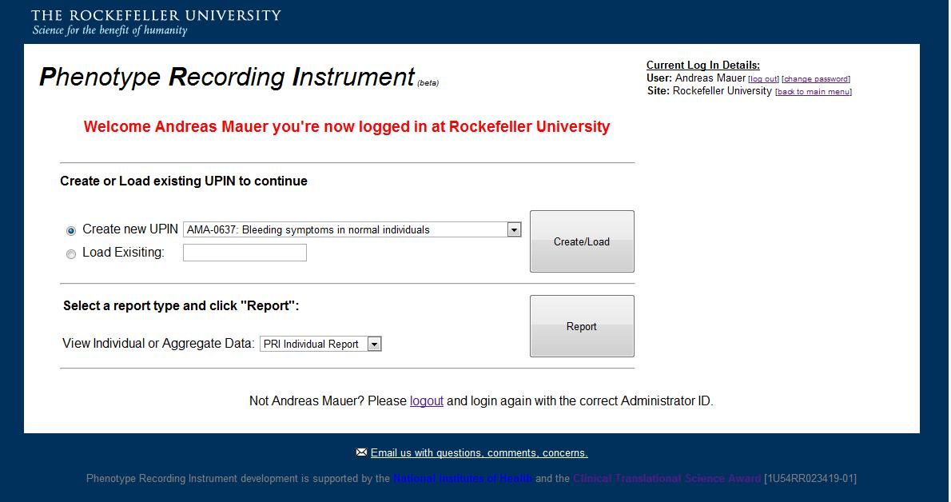

Several options can be selected from this menu. If it is the first time you are using the instrument, we recommend that you begin by changing your password. Begin by clicking the “change password” link:

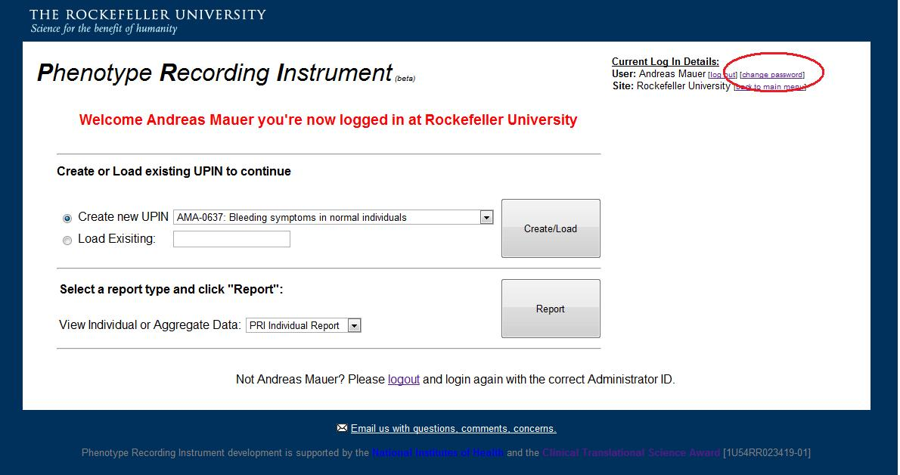

This will open a new window:

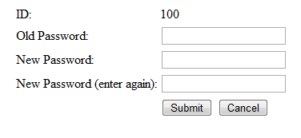
Fill out the fields to change your password. Guidelines for creating secure passwords can be found here: http://www.microsoft.com/protect/fraud/passwords/create.aspx

If you ever forget your password, please email us and we will assist you.

Once you are satisfied, you may begin a new questionnaire by using the “Create new UPIN” menu:

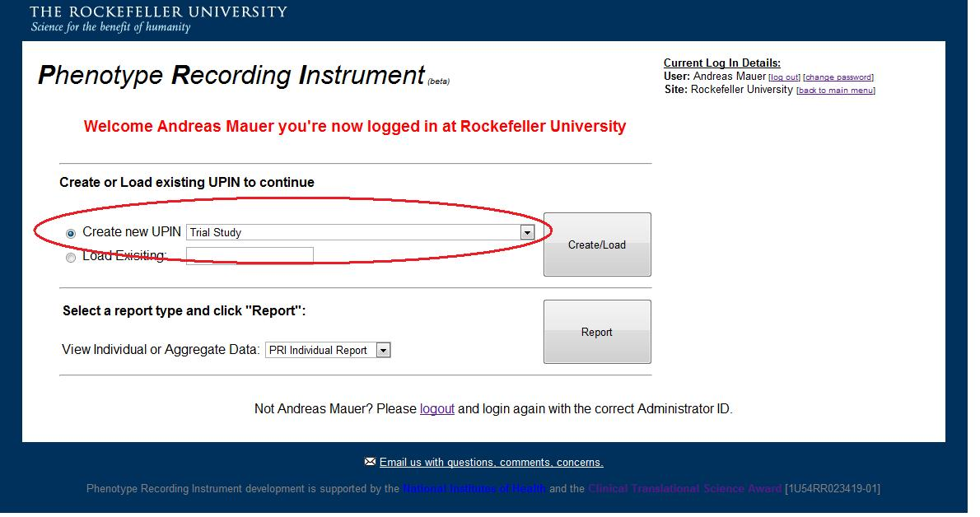

Depending on your specific needs, the system offers different users different data collection instruments. The instruments that are offered are defined at the time that your group sets up a study with the RUBHPSR staff. In this example, we will use the “Trial Study” option. Any data collected under this study template are identified as being test data and unsuitable for analysis, so please be careful to use this option when testing out the instruments! After selecting the right option from the dropdown menu, click the button labeled “Create/Load.”

Clicking this button will create a new Unique Personal Identification Number (UPIN).

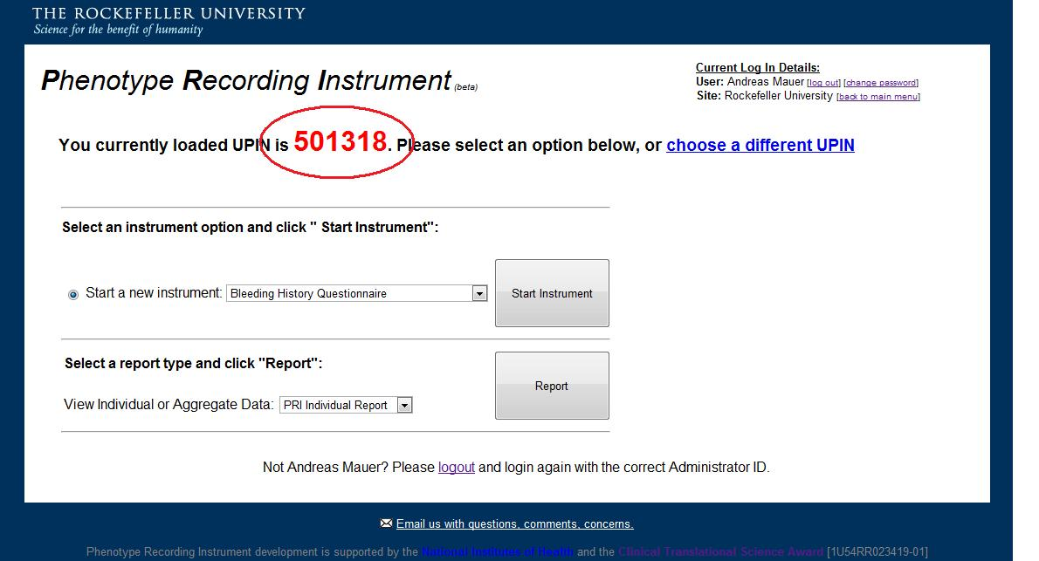
A UPIN can be thought of as the identifier for a single individual or patient. You can complete multiple instruments under a single UPIN. For example, I might fill out the Rockefeller University Bleeding History Questionnaire and enter laboratory results under a single UPIN, or even complete the same questionnaire twice. If you are finished with an individual and want to enter data for a new individual, click “choose a different UPIN:”
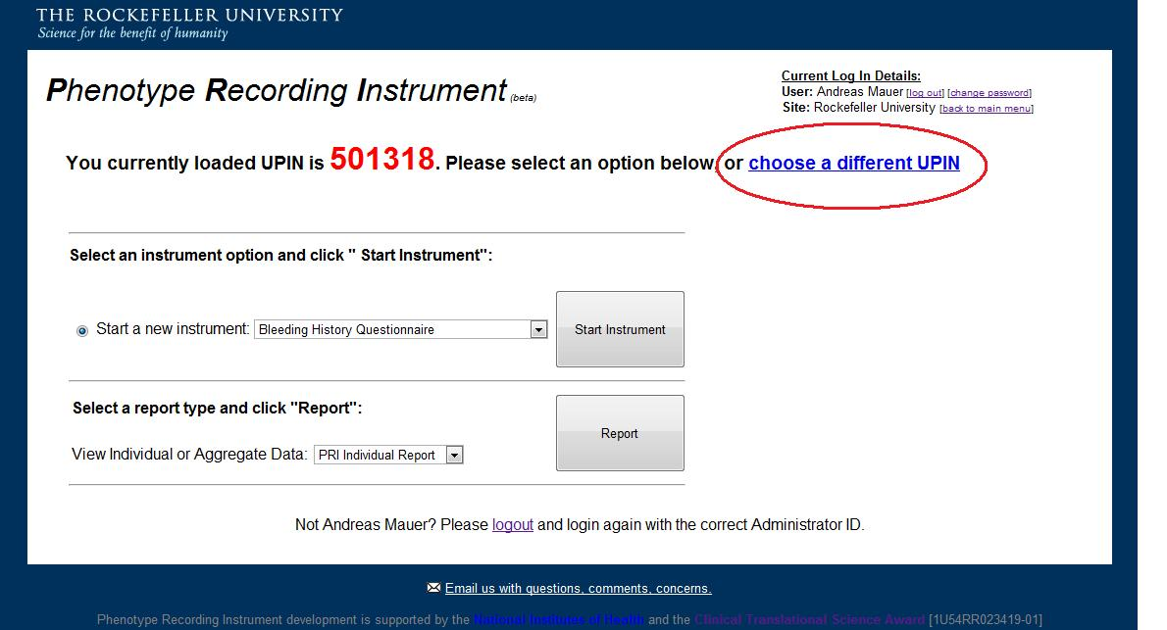
Doing this will return you to the main screen. At the main screen, you can create another new UPIN, or return to an existing UPIN to enter additional data. To return to an existing UPIN, you must know the UPIN that you want to add data to. UPINs are linked to your login IDs, so you will only be able to add data to UPINs that were created at your institution. To return to an existing UPIN, enter the UPIN into the box labeled “Load Existing,” then click the button labeled “Create/Load:”
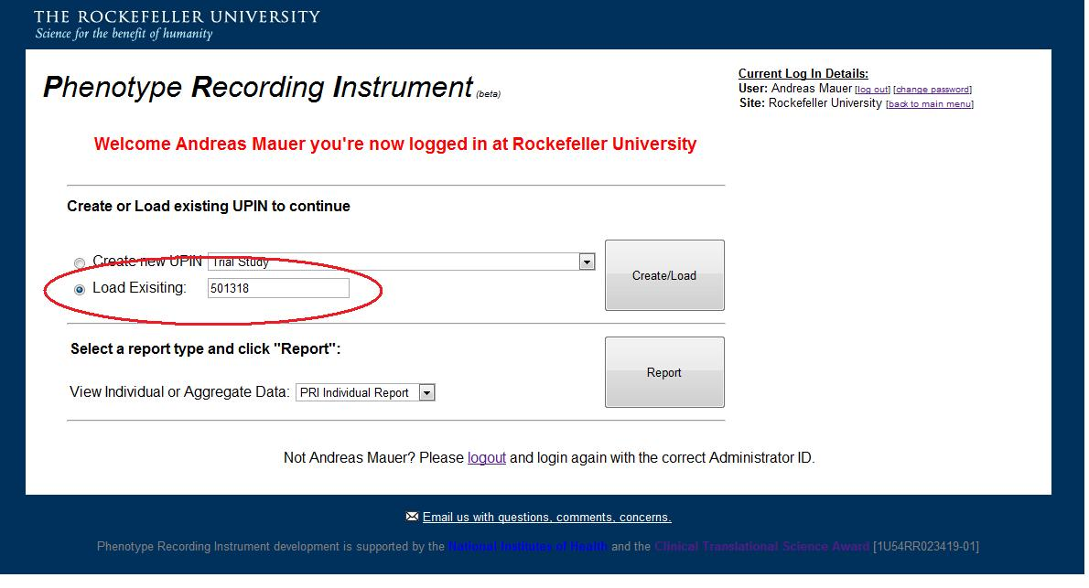
The next screen should look familiar. You can now start a new data collection instrument by using the “Start a new instrument” dropdown menu. We suggest that you begin by testing out the Rockefeller University Bleeding History Questionnaire (RU BHQ). Select “Bleeding History Questionnaire” and click “Start Instrument:”
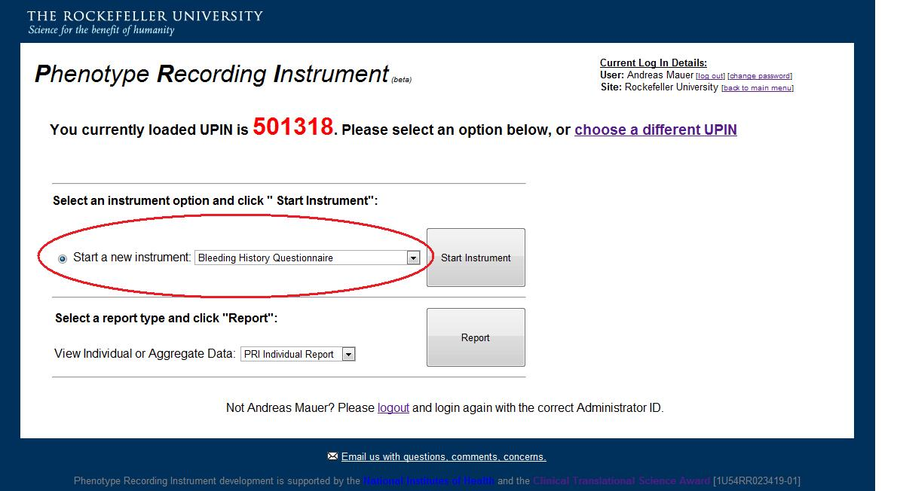

3. To complete the questionnaire:
The RU BHQ is a comprehensive questionnaire for collecting a standardized bleeding history. The start page for the RU BHQ is displayed below. The upper right corner displays your login information, including:
- Your username
- The site where you are logged in
- The UPIN that you are currently working with
- Which study template you are working under
- How long you have been working on the current instrument.

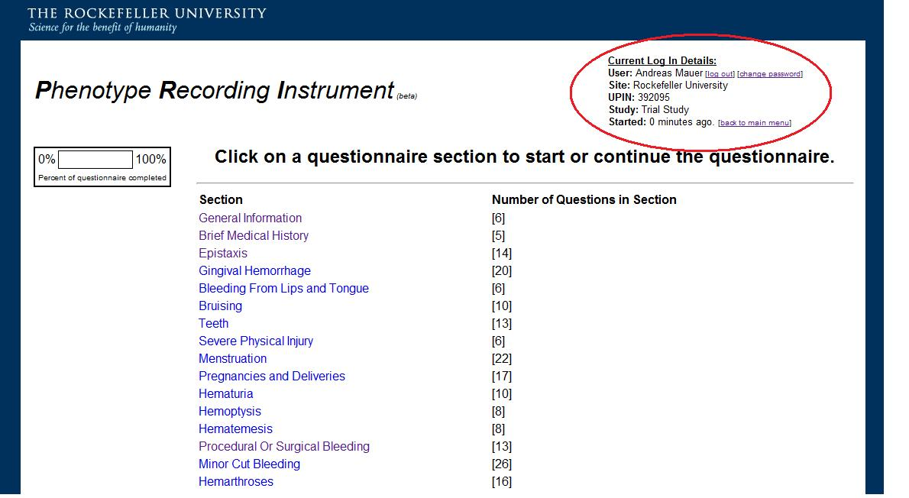

A. To start the questionnaire, click “General Information.” The Web browser will be automatically directed to the first question block.
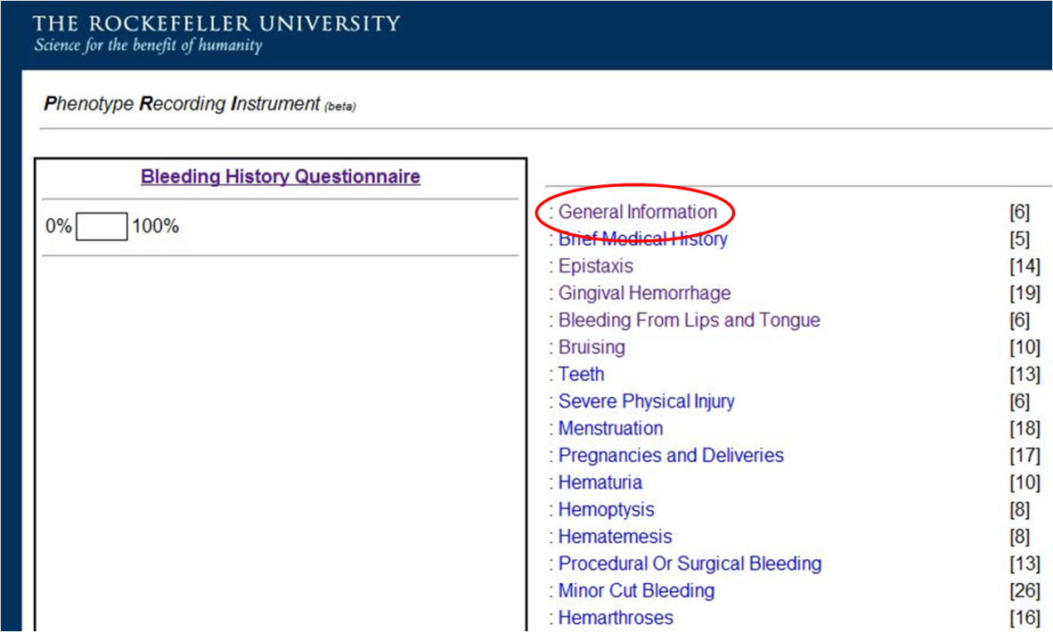
B. To complete a specific question block, click the link to the desired block.
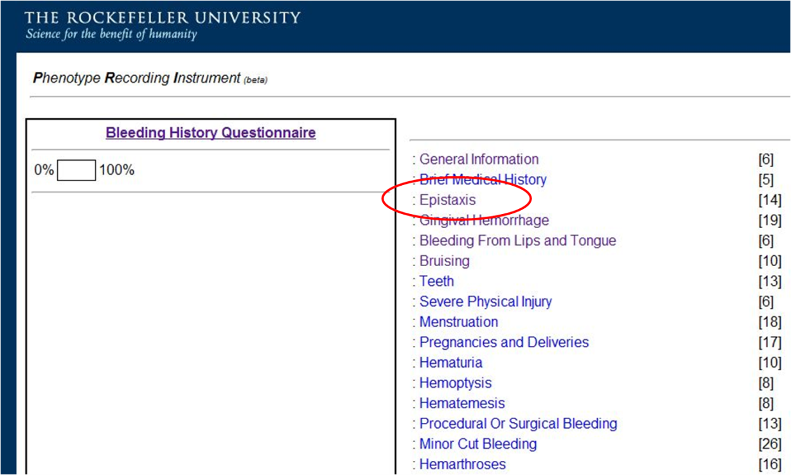
C. To log out at any time, click “log out” in the top right corner.
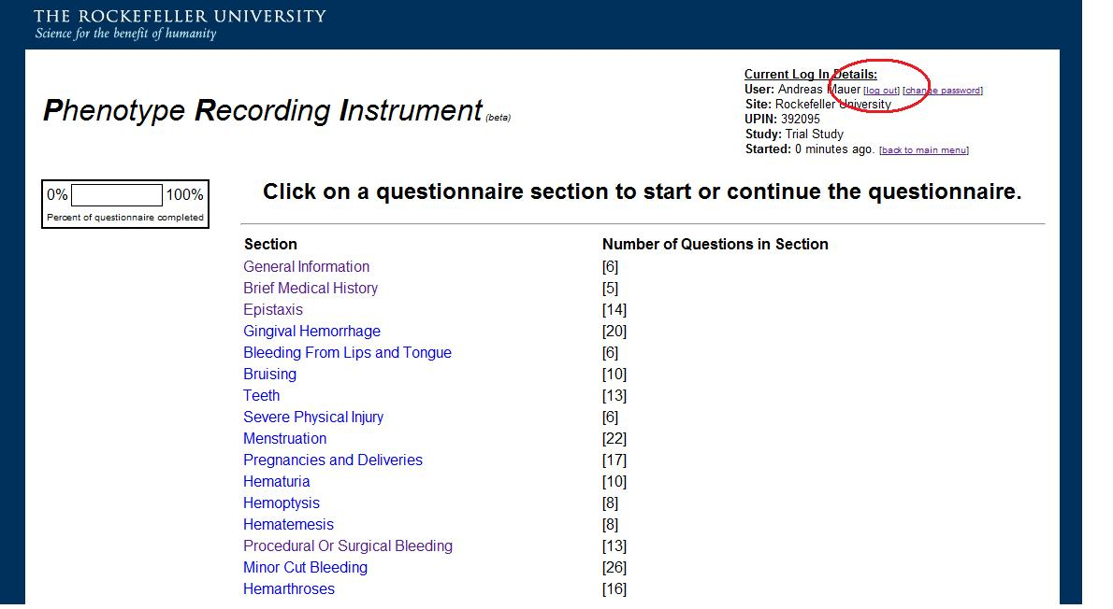
F. To skip to a new question block at any time, click “Bleeding History Questionnaire” in the left sidebar. The next screen will display the list of question blocks. Completed question blocks are indicated by a strikethrough bar. On this screen, the percentage of completed questions is displayed in the left sidebar.

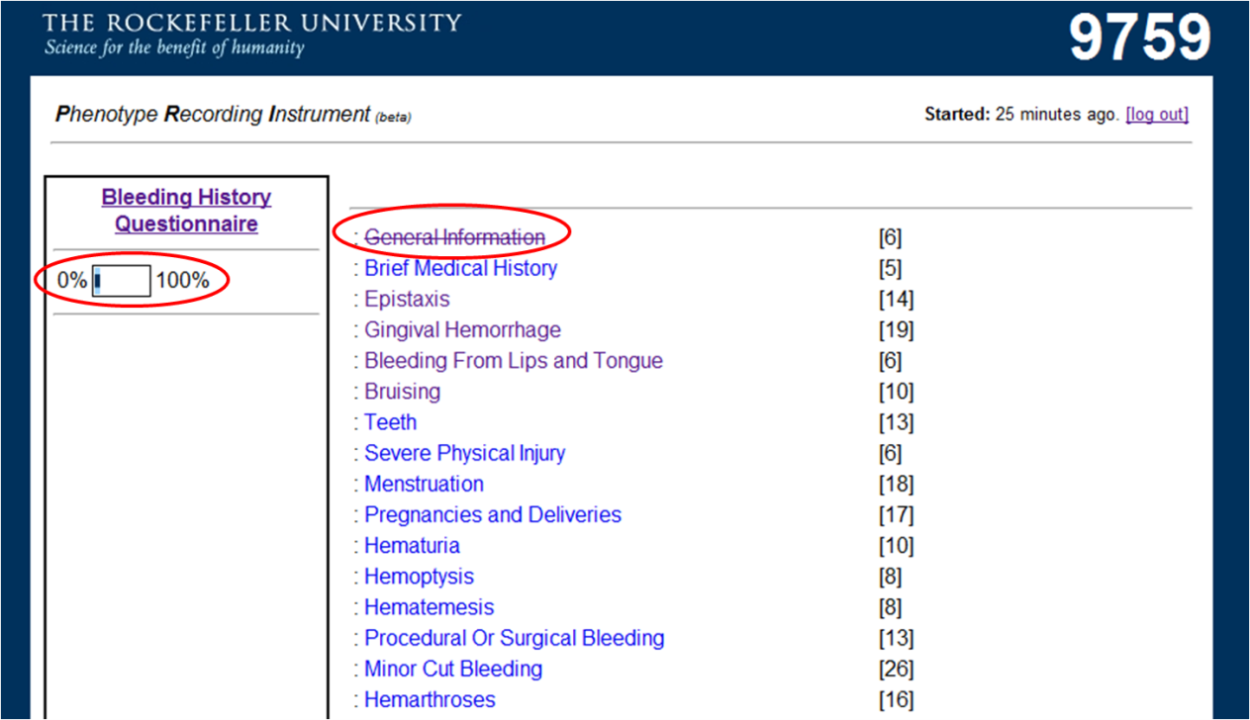
G. To answer a question, click the radio button or check box next to the appropriate answer. For free-text responses, type the answer into the appropriate text box.
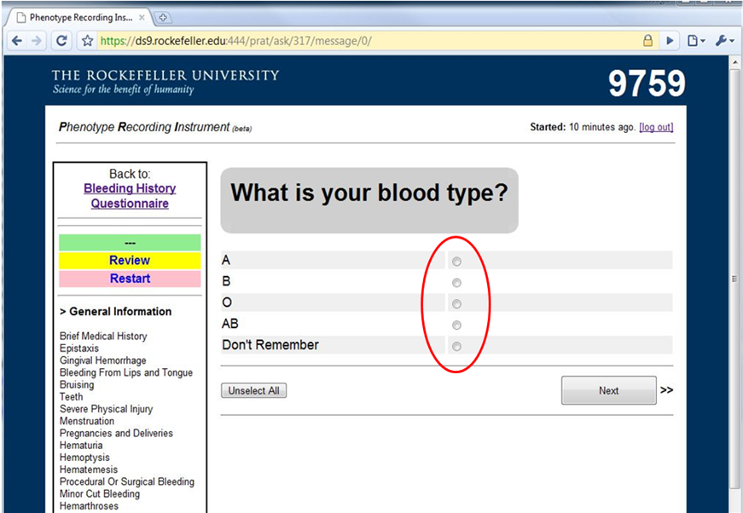
H. When a question is complete, click “Next” to proceed to the next question.
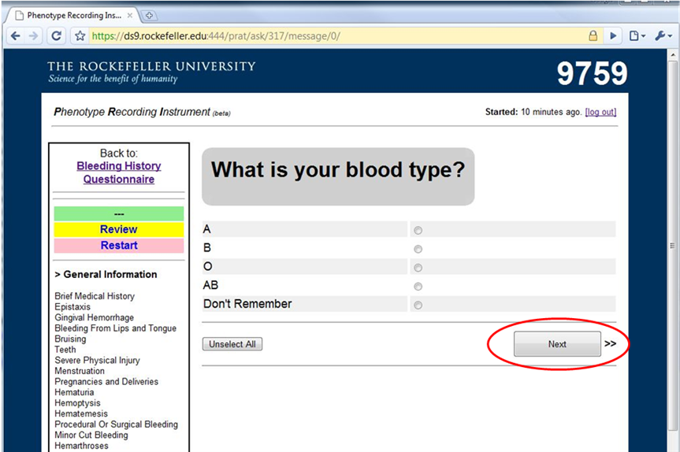
I. To correct an entered question response, click the “back” button on the web browser until the browser cycles back to the desired question. Change the answer and click “Next.” The previous answer will be erased from the database.
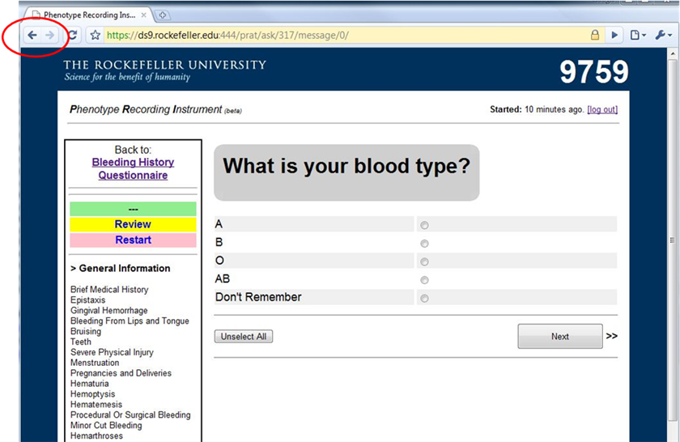
J. To erase all the data within a question block and return to the beginning of the block, click “Restart.”
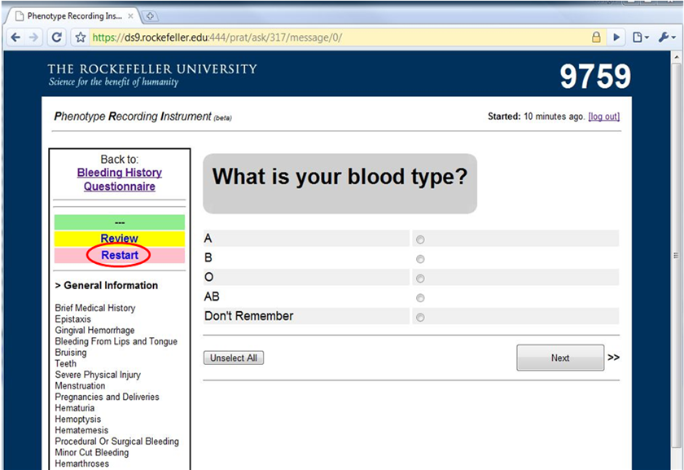
K. To review completed question responses, click “Review.”
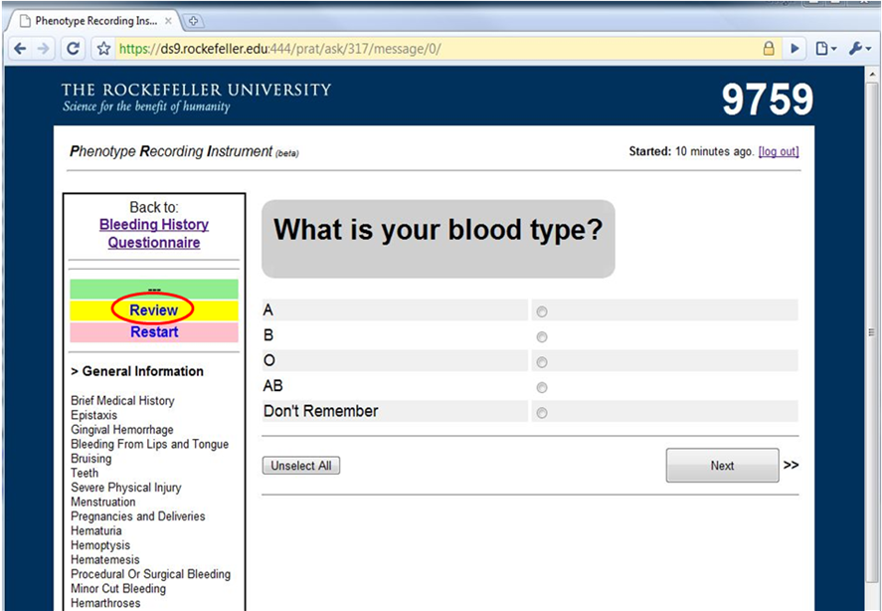
J. After the last question is complete, you will be directed to this page:
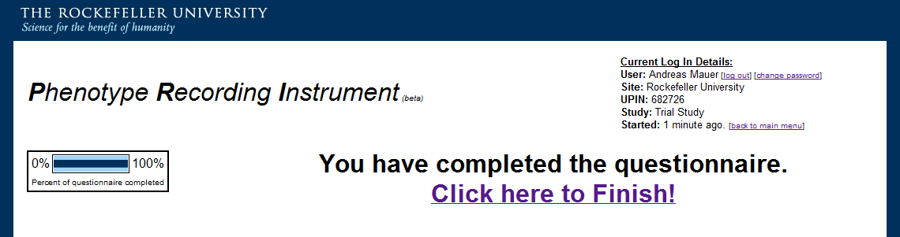
Click the “Click here to Finish!” link to return to the main menu. If you do not click this link, the instrument you just completed will not be closed out. This won’t endanger your data, but will alter other important elements within the system – for example, the system won’t know to stop the timestamp.

4. Laboratory Data Entry Instrument:
Selected laboratory results pertaining to hemostasis can be entered using the “Lab Instrument.” To enter labs, create a new UPIN or load an existing UPIN as described above, then select “Lab Instrument” from the dropdown list and click “Start Instrument:”
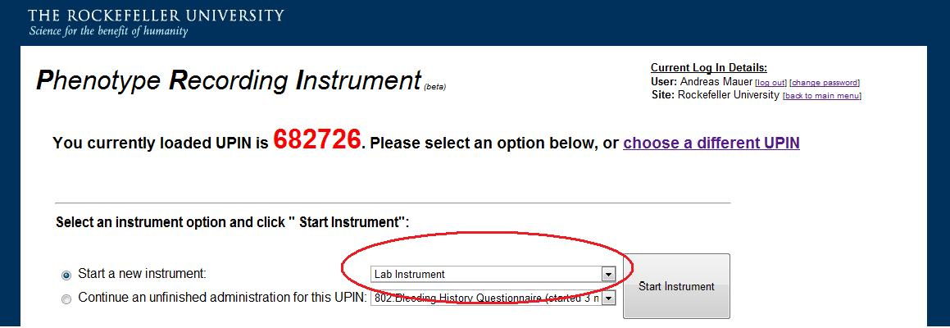
A. The data entry page is organized by the type of test to be entered. To enter a laboratory result, click the “+” sign next to the type of test that you want. In this example, we will add a hemoglobin value.
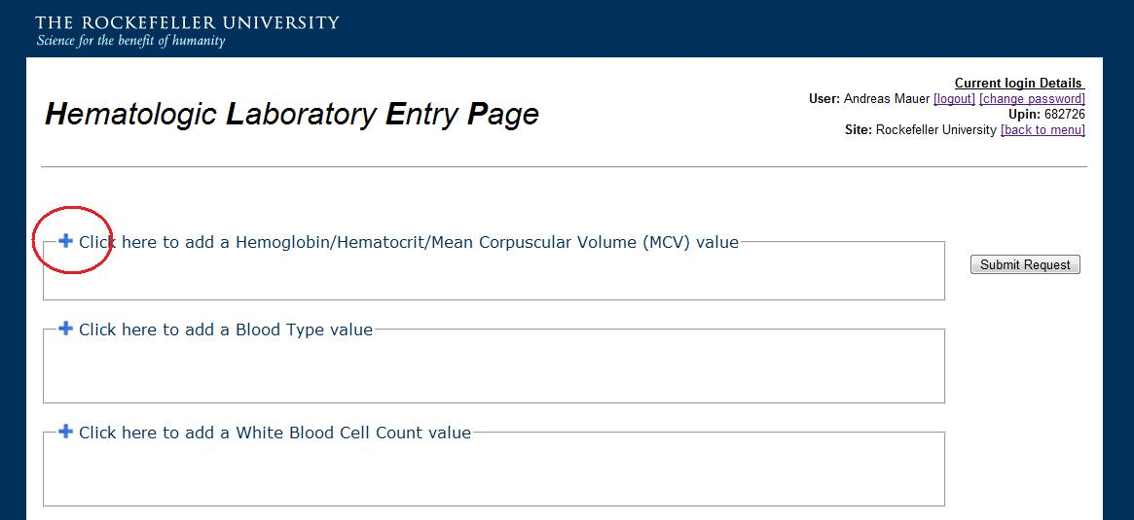
B. A new menu will appear. Choose the laboratory test you are interested in, the units of measurement for that test, and enter the value.
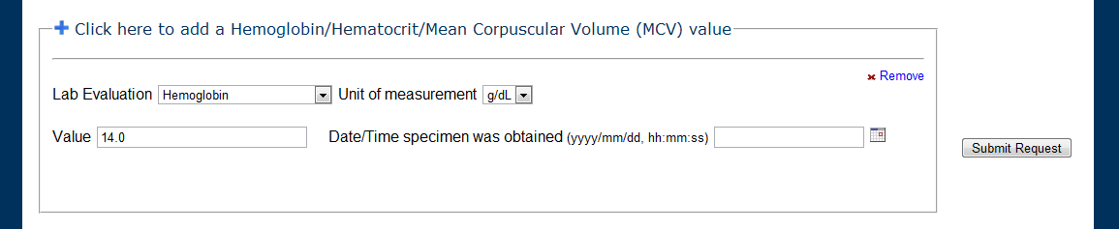
C. To enter the date and time that the lab test was processed at, click the calendar icon. You can also enter the date and time yourself, but the calendar will help to ensure that the standardized format is used.
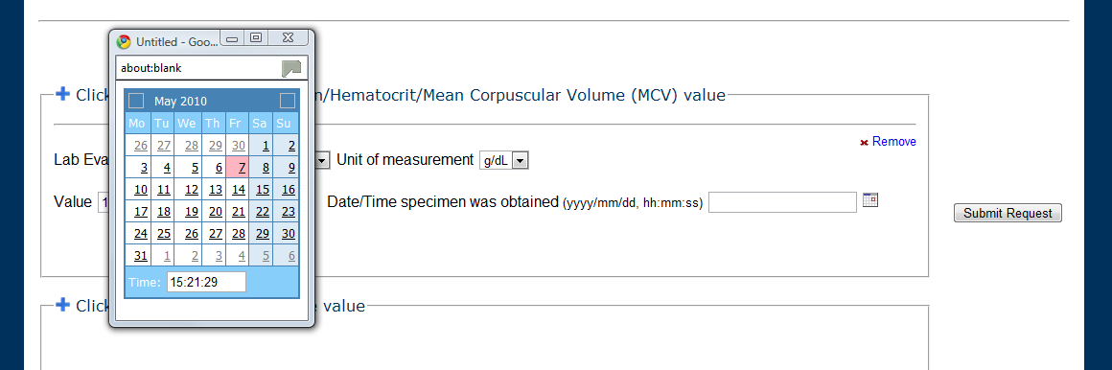
D. Click “submit request.” The data you entered will not be stored if you do not complete this step.
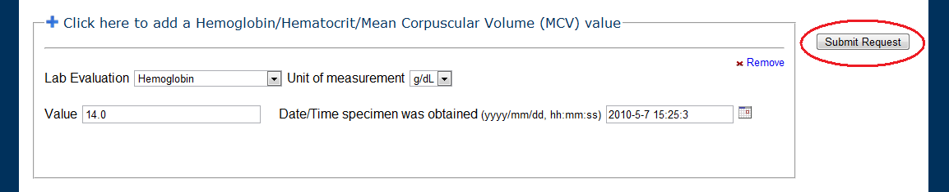
E. You can also add several laboratory results in a batch before submitting.
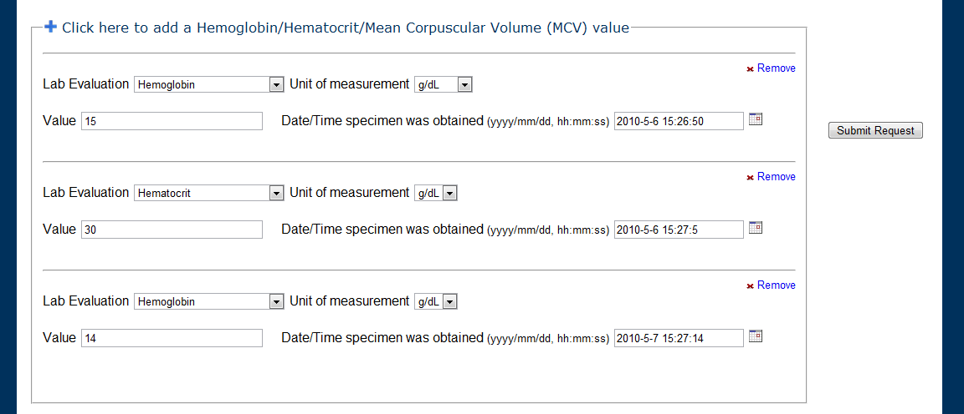
F. If you make an error, you can remove the erroneous result by clicking “Remove.”
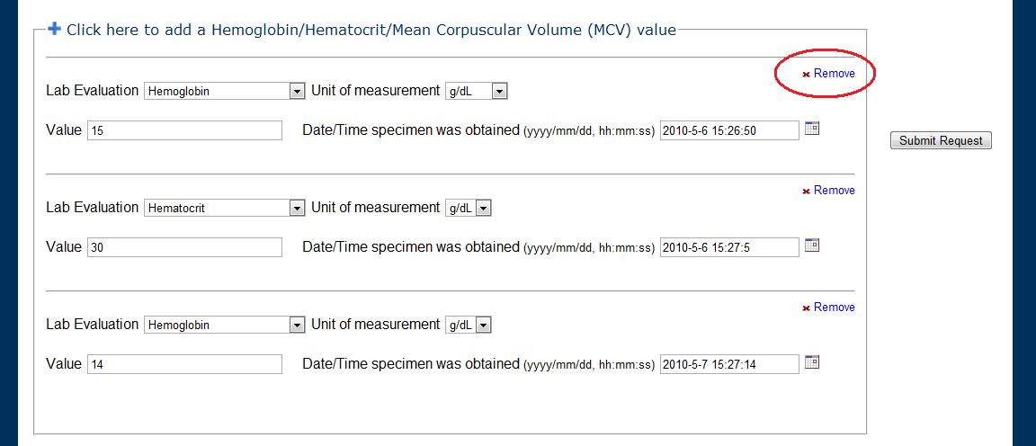
G. Some laboratory tests have special data entry fields. For example, the results of von Willebrand factor multimeric analysis are selected from a dropdown list:
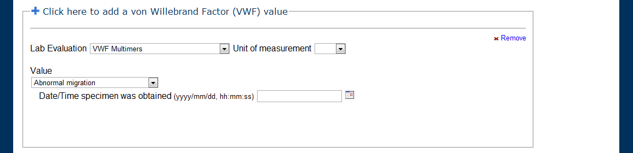
G. After you submit your data, you will be taken to a summary page so you can review the results.
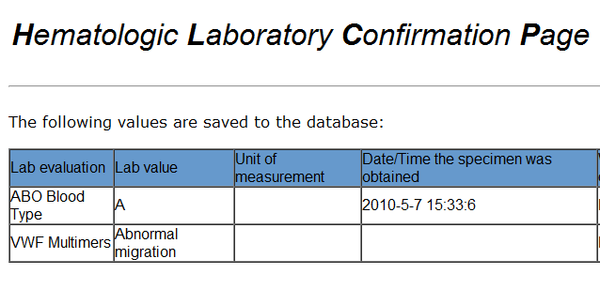
H. To enter additional laboratory results, click the “Back to lab page” link.
J. When you are done, click “back to menu” to return to the main page.

II. PRI Reports
PRI Reports is a suite of database query and data representation utilities. PRI Reports currently includes four utilities:
- PRI Demographics
- PRI Graph
- PRI Individual Report
- PRI Aggregate Report.

For additional details on each of these utilities, please visit the RUBHPSR Webpage.

A. To choose a PRI Report utility, select the desired utility from the dropdown menu labeled “View Individual or Aggregate Data” and click “Report.”
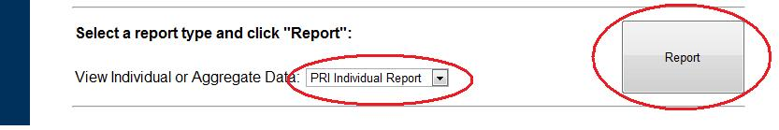
B. We will now walk through each of the four PRI Reports utilities.

1. PRI Demographics - Generates pie charts depicting the reported race, ethnicity, and sex of questionnaire respondents.
1. Select “Demographics Report” from the PRI Reports dropdown menu and click “Report.”
2. Check the desired study (studies), site(s), user(s), and instrument(s); this will filter the data to display only demographic characteristics from the desired subjects.
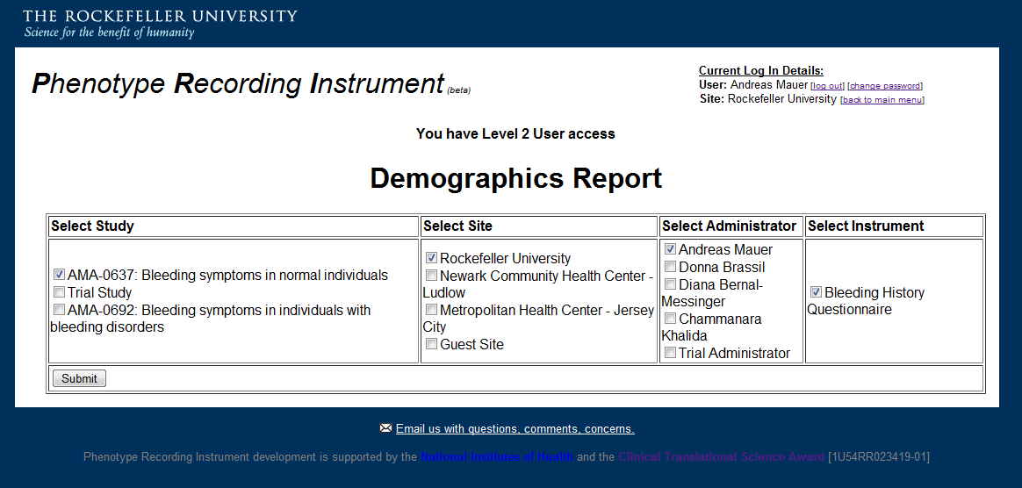
3. Click Submit.

2. PRI Graph – generates bar graphs that summarize responses collected with the Bleeding History Questionnaire/Phenotype Recording Instrument.
1. Select “Graph Report” from the PRI Reports dropdown menu and click “Report.”
2. Check the desired study (studies), site(s), and user(s); this will filter the data to display only the question responses from the desired subjects.
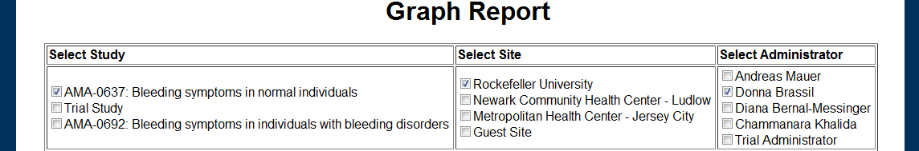
3. Check the desired questionnaire section(s). All questions within the checked section(s) will be graphed.
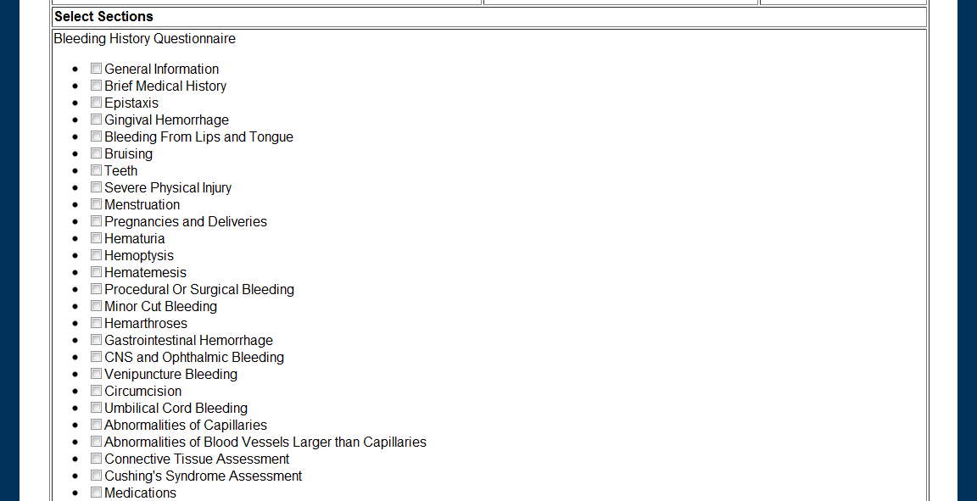
4. Click Submit.

3. PRI Individual Reports – retrieves any single individual’s responses to the Bleeding History Questionnaire/Phenotype Recording Instrument in a printable pdf.
1. Select “PRI Individual Report” from the PRI Reports dropdown menu and click “Report.”
2. Enter the UPIN of the respondent whose responses you would like to retrieve. You will only be able to query UPINs that you are authorized to access. For further details on how access to data is limited, please see the Standard Operating Procedures, available from http://bh.rockefeller.edu/RUBHPSR/Documentation.html.
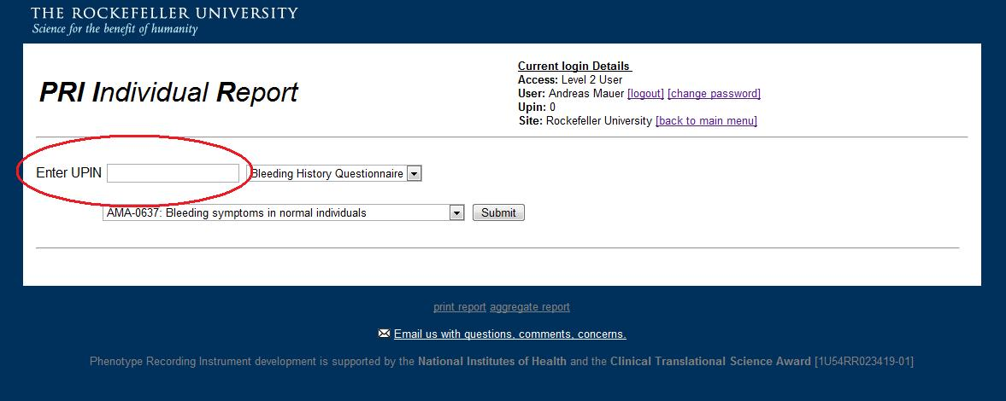
3. Select the type of questionnaire you want to query.
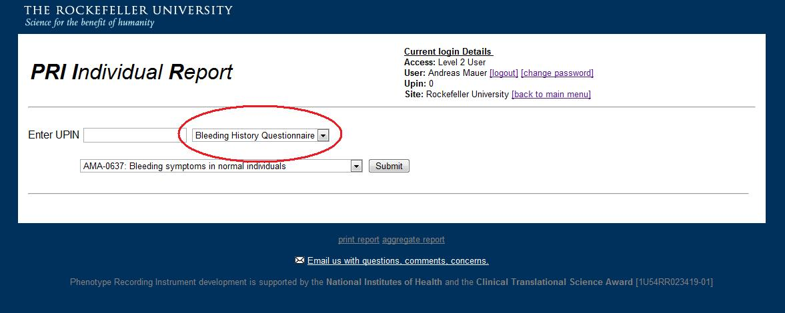
4. Select the study under which the respondent was evaluated.
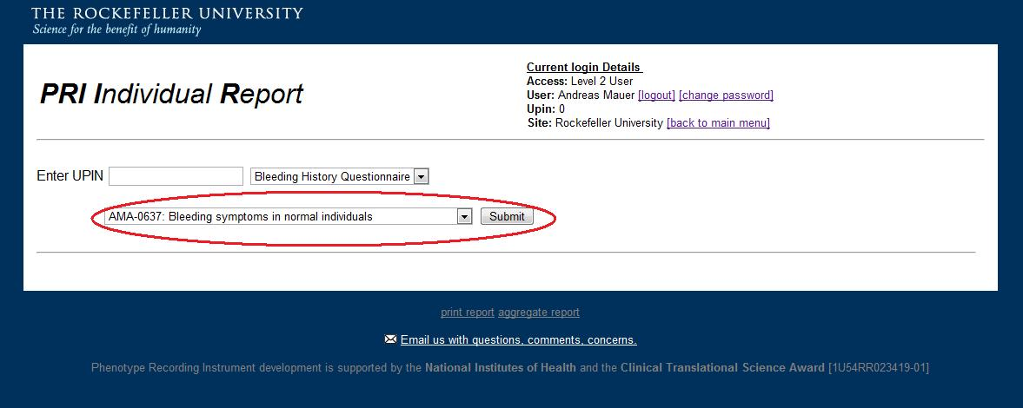
5. Click “Submit.”

4. PRI Aggregate Reports – Allows the user to query all responses to one of the data administration instruments across selected subsets of individuals. Produces a spreadsheet suitable for statistical analyses.
1. Select “PRI Aggregate Report” from the PRI Reports dropdown menu and click “Report.”
2. If you would like to filter the report to display only results from a single questionnaire administrator, select that person using the “Select Admin” box. If you would like to query the database for all records, regardless of who administered the questionnaire, select “All.”
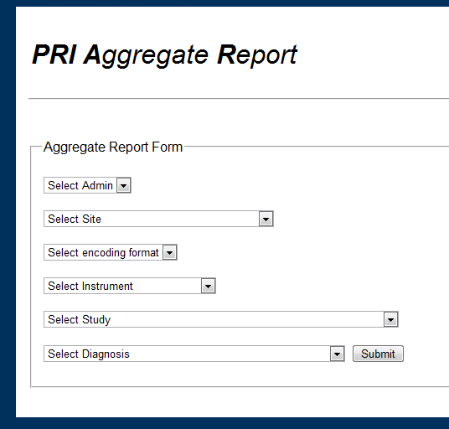
3. If you would like to filter the report to display only results from a single site of questionnaire administration, select that site using the “Select Site” box. If you would like to query multiple sites, run a separate query for each site and then merge the spreadsheets after they have been generated.
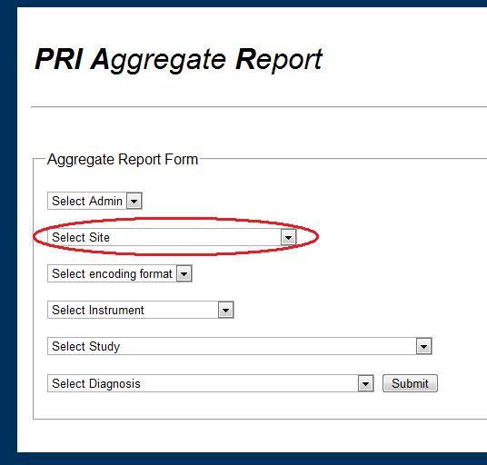
4. Aggregate PRI Reports can display the retrieved information in two formats: text and numeric. The text format uses the exact wording of responses to questions in the Bleeding History Questionnaire/Phenotype Recording Instrument. The numeric format converts responses to numeric values that may be more suitable for some analyses. To select the format, select “text” or “numerical” from the “Select encoding format” box. A key to the numeric coding is available from the “Documentation” page on the RUBHPSR Website: http://bh.rockefeller.edu/RUBHPSR/Documentation.html
5. To filter the report to display results that were collected using a single instrument (e.g., the Rockefeller University Bleeding History Questionnaire or the laboratory data instrument), use the “Select Instrument” menu.
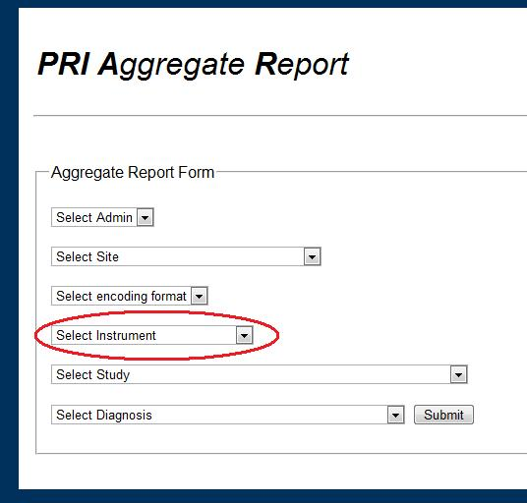
6. To filter the report to display results from a single study, select that study using the “Select Study” box. If you would like to query multiple studies, run a separate query for each study and then merge the spreadsheets after they have been generated.
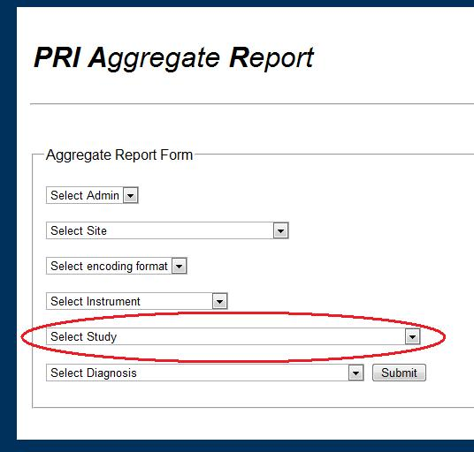
6. To filter the report to display results individuals with a single bleeding disorder diagnosis (e.g., “von Willebrand disease,”) select that diagnosis using the “Select Diagnosis” box. If you would like to query multiple diagnoses, run a separate query for each diagnosis and then merge the spreadsheets after they have been generated.
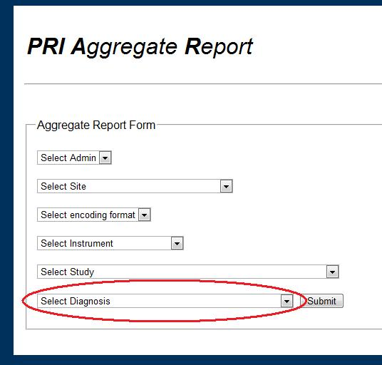
7. Click “Submit.”

